PROJECT REPORT

PHASE II

**1- Project Members**

İlayda Nihal Arıkan 160709020

Elif Nur Şağban 160709047

Our project data content is about killings by police and informations of that. We tried to work on Mysql for our project. Also examine detaily datas of criminal’s killings by police officers and look into widely perspective of the incident.

**2-Changes**

We changed our er-diagram so our schema should be more likely to 3-NF format . We renamed some column names in csv file to achieve our er-diagram should be more understandable.We add foreign keys to csv file as auto increment values because of we have no unique column and primary key and we had to create our primary key as auto increment value and Mysql didn’t allow us to make the second auto increment . We couldn’t find any solution about that.

**3-Data Load**

Firstly, we did denormalized table and write all the column names as entity and exact order in csv file. Than we used LOAD DATA parameter and secure_file_priv option to add csv file into the Mysql path. We managed to load all our data.

**4-**We used Mysql Workbench8.0

**5-**View/Stored procedure

We created 2 views from city and location and we wrote a small query to try views. We created 3 stored procedures for try to in, out, inout procedures.

**6-**

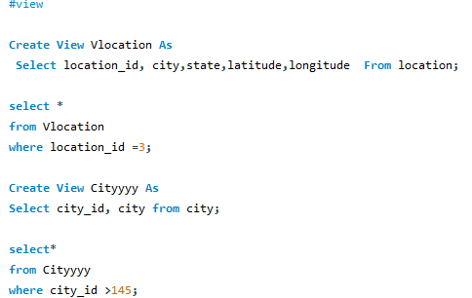

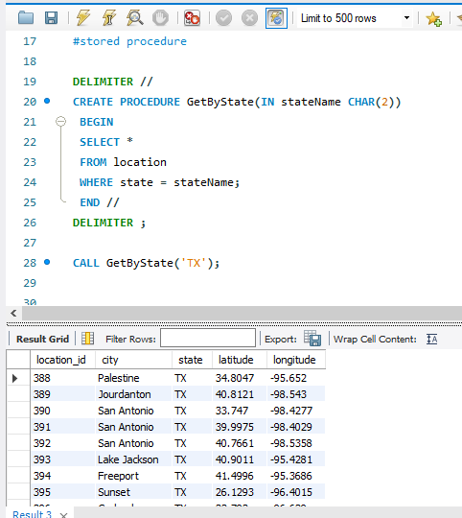

**7-**Analysis of our system’s limitations

There isn’t any unique data in our source file that was our limitation. Managing data types for columns and insert into part denormalized table to er-diagrams.While we were creating combined date we had a trouble with data value in month column. We solved that but still it stores as null.

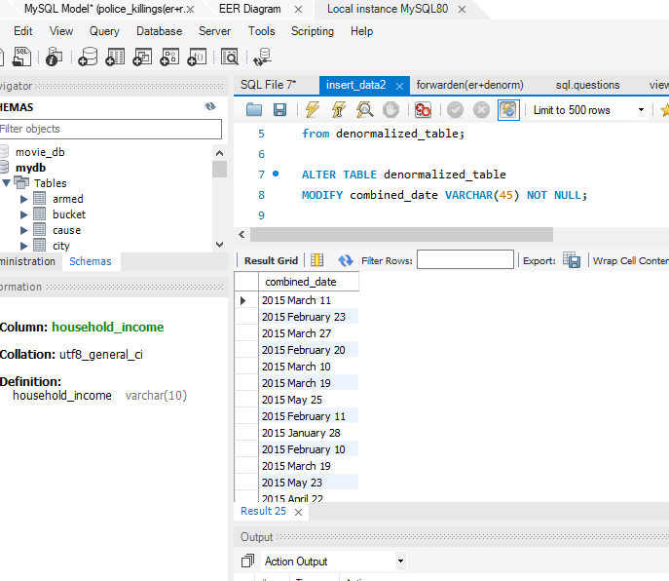

**9-**Data-Acquisition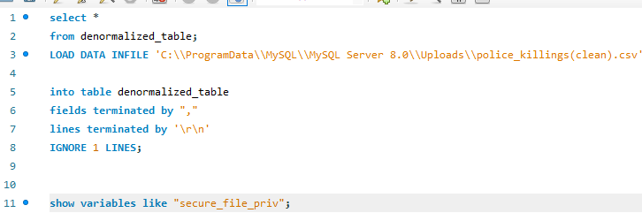

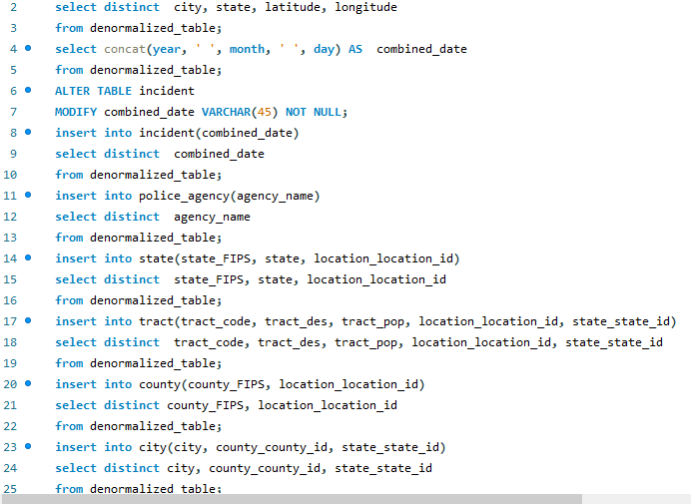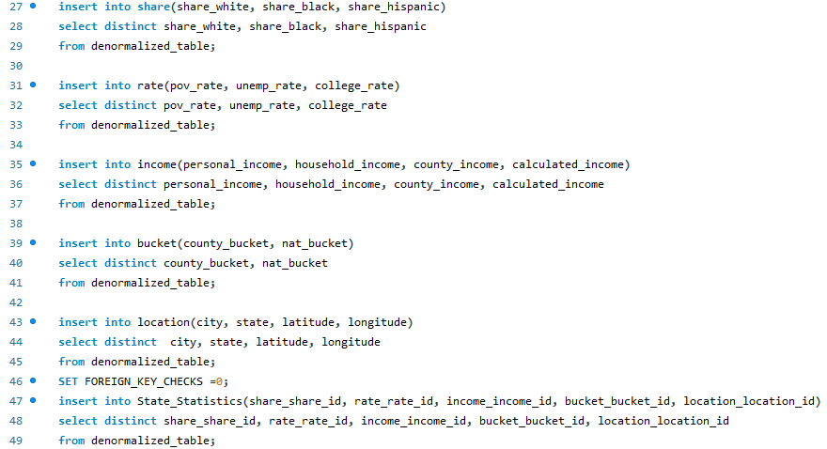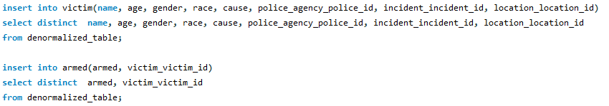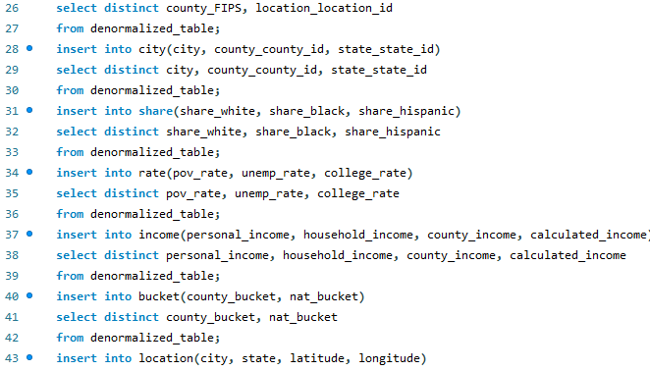

ER-DIAGRAM

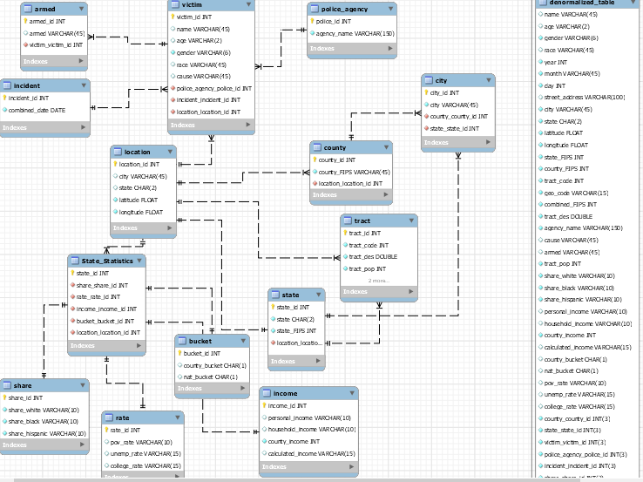

SQL-QUESTIONS

